A PROJECT REPORT ON

SOCIAL MEDIA SENTIMENT ANALYSIS FOR
PRODUCT DEVELOPMENT AND FEATURE IMPROVEMENT

Submitted in partial fulfillment of the requirements for the
APSSDC INTERNSHIP PROGRAM

SUBMITTED BY:
Sanku Meghana
Tulasi Gowri Athi
Reddy Gayathri
Katta S V S Kalyan
Paruchuri Venkatesh
Kanaparthi Geetanjali

TOOLS & TECHNOLOGIES:
Python | Pandas | Natural Language Processing (NLP)



DECLARATION

We hereby declare that the project report entitled "SOCIAL MEDIA SENTIMENT ANALYSIS FOR PRODUCT DEVELOPMENT AND FEATURE IMPROVEMENT" submitted in partial fulfillment of the requirements for the APSSDC Internship Program, is a bona fide record of the original work carried out by our team.
The analytical models, data cleaning pipelines, and insights embodied in this report have not been submitted to any other University or Institution for the award of any degree or diploma. The methodologies applied reflect our direct practical application of Python, Data Analytics, and Natural Language Processing concepts.

Date: July 2026

Team Members:
Sanku Meghana
Tulasi Gowri Athi
Reddy Gayathri
Katta S V S Kalyan
Paruchuri Venkatesh
Kanaparthi Geetanjali

ABSTRACT

In the contemporary digital ecosystem, customer feedback is generated at an unprecedented scale. Manually reading, categorizing, and interpreting this feedback is practically impossible for modern software organizations. This project, "Social Media Sentiment Analysis for Product Development and Feature Improvement," addresses this challenge by automating the extraction and classification of sentiments from Google Play Store app reviews.
Utilizing Python and Natural Language Processing (NLP) libraries, a large-scale dataset of unstructured user reviews was ingested, cleaned, and systematically analyzed. The raw text was heavily preprocessed to remove conversational noise—including URLs, mentions, special characters, and punctuation—and normalized through stopword removal and lemmatization. The cleaned data was then subjected to exploratory data analysis (EDA) and automated sentiment classification, categorizing each review as Positive, Negative, or Neutral based on algorithmically calculated polarity scores.
The results highlight recurring issues such as performance problems, software bugs, and update-related usability concerns from negative reviews, while simultaneously isolating successful features from positive feedback. By transforming unstructured text into visual dashboards (including word clouds, sentiment distributions, and missing value heatmaps), this project provides product managers and development teams with an actionable, data-driven framework. Ultimately, this automated pipeline allows organizations to identify critical software bugs proactively, prioritize feature requests accurately, and monitor overall brand health without the need for manual review tracking.

INTRODUCTION

2.1 Project Overview
The modern software development lifecycle relies heavily on continuous user feedback. While quantitative metrics, such as star ratings or daily active users (DAU), provide a surface-level view of application performance, the contextual "why" is buried in unstructured text. This project bridges the gap between raw customer feedback and actionable engineering tasks. By deploying an automated Data Analytics and NLP pipeline, this project parses, cleans, and evaluates the text of thousands of app reviews to uncover hidden user insights.

2.2 Problem Statement
Large volumes of customer feedback make it difficult to manually analyze sentiment and identify meaningful insights. Product managers and development teams require an automated solution to sift through daily reviews. Without automation, critical bugs reported by users often go unnoticed until they cause widespread application churn. This project aims to automate sentiment classification to better understand customer opinions, flag critical issues instantly, and support targeted product improvement.

2.3 Business Use Case
Companies frequently struggle to parse through thousands of daily app reviews to determine what users love or hate about their software. Automating this process allows product managers and development teams to:
- Swiftly identify critical bugs and crashes.
- Track and aggregate feature requests.
- Monitor overall brand perception following new software updates. This transforms unstructured textual feedback into structured, data-driven decisions that enhance Return on Investment (ROI) and customer retention.

2.4 Objectives
The primary objectives of analyzing these Google Play Store reviews are to:
- Automate the ingestion and cleaning of highly unstructured textual data.
- Understand overall user sentiment across a wide variety of mobile applications.
- Identify specific positive and negative feedback trends reliably.
- Discover frequently discussed features and major customer pain points through keyword extraction.
- Visualize sentiment patterns using comprehensive dashboards to communicate technical findings to non-technical stakeholders effectively.

SYSTEM REQUIREMENTS

To execute this Data Analytics and Natural Language Processing pipeline efficiently, the following system requirements must be met.

3.1 Operating System
- Primary OS: Windows 10 or Windows 11 (64-bit).
- Alternatives: macOS (Monterey or later) or Linux (Ubuntu 20.04 LTS or later) are fully supported as Python is highly cross-platform.

3.2 Software Requirements
- Programming Language: Python 3.8 or higher.
- Integrated Development Environment (IDE): Jupyter Notebook, JupyterLab, or Google Colaboratory (recommended for inline data visualization and cell-by-cell debugging).
- Package Manager: pip or conda for installing dependencies.
- Core Libraries to Install:
  - pandas (Data manipulation)
  - numpy (Numerical computation)
  - matplotlib & seaborn (Data visualization)
  - nltk (Natural Language Toolkit for text processing)
  - textblob (Sentiment polarity calculation)
  - wordcloud (Visual keyword mapping)
3.3 Hardware Requirements
- Processor (CPU): Intel Core i3 / AMD Ryzen 3 (Minimum) | Intel Core i5 / AMD Ryzen 5 or higher (Recommended for faster text tokenization).
- Memory (RAM): 4 GB RAM (Minimum) | 8 GB to 16 GB RAM (Recommended for handling large Pandas DataFrames in memory without bottlenecking).
- Storage Space: Minimum 500 MB of free disk space for Python installation, virtual environments, and dataset storage. Solid State Drive (SSD) is recommended for faster dataset read/write operations.

ARCHITECTURE OF PROJECT

4.1 High-Level System Overview
Processing unstructured text requires a specialized, sequential workflow. Unlike numerical data, social media reviews contain chaotic conversational noise. This project's architecture is a linear pipeline that systematically strips noise, analyzes emotional weight, and renders business intelligence. The system operates in five distinct phases: Data Acquisition, Noise Reduction, Linguistic Tokenization, Sentiment Stratification, and Visual Intelligence.
4.2 Phase 1: Data Acquisition and Memory Ingestion
The pipeline begins by ingesting the Google Play Store reviews dataset.
- Data Source: Provided in CSV format for efficient flat-file storage.
- Memory Mapping: Python’s Pandas library parses and loads the CSV into RAM as a DataFrame.
- Initial Auditing: The system audits data types and record counts, identifying structural columns (App, Translated_Review, Sentiment) for downstream processing.
4.3 Phase 2: Data Preprocessing and Noise Reduction
Raw social media data must be filtered to prevent downstream computational errors.
- Null Value Eradication: Rows containing missing (NaN) reviews are algorithmically dropped to prevent pipeline crashes.
- Text Normalization: All valid strings are converted to lowercase to ensure uniform tokenization.
- Regex Filtration: Python’s Regular Expressions module strips non-sentiment elements, including URLs, user tags, numerical digits, and special punctuation, leaving only pure alphabetical strings.
4.4 Phase 3: Linguistic Processing (NLP Tokenization)
The sanitized text undergoes linguistic processing using the Natural Language Toolkit (NLTK).
- Stopword Removal: Connective words (e.g., "the", "is") carry zero polarity. These are deleted using NLTK’s Stopwords Corpus to reduce dimensionality.
- Morphological Lemmatization: The WordNetLemmatizer reduces varying verb tenses (e.g., "crashing", "crashed") into their base dictionary root ("crash"), ensuring accurate frequency aggregation.
4.5 Phase 4: Sentiment Stratification and Algorithmic Scoring
The lemmatized dataset is passed to TextBlob for sentiment scoring.
- Lexicon-Based Scoring: TextBlob evaluates each string against an internal dictionary of emotionally weighted words.
- Polarity Calculation: The algorithm outputs a Polarity float from -1.0 (absolute negative) to +1.0 (absolute positive), with 0.0 representing neutral.
- Dataset Stratification: Based on these thresholds, the master DataFrame is split into Positive, Negative, and Neutral sub-datasets to isolate bug reports from feature praises.

4.6 Phase 5: Visual Intelligence and Dashboard Rendering
Raw polarity scores are translated into human-readable graphics for business stakeholders.
- Rendering Engines: Segmented datasets are passed to Matplotlib and Seaborn.
- Macro-Level Visualization: Pie charts and bar graphs display the macro-level health of the applications.
- Micro-Level Visualization: WordCloud generates visual frequency maps from the negative dataset, creating an intuitive visual bug report of frequently mentioned software failures.
4.7 Data Flow Summary
This sequential pipeline undergoes four critical state transitions:
- Raw (Ingestion): Data enters memory as chaotic text.
- Sanitized (Filtration): Pandas and Regex strip nulls and non-alphabetical characters.
- Tokenized (Linguistic Processing): NLTK removes stopwords and lemmatizes words into core semantic roots.
- Quantified & Visualized (Scoring & Rendering): TextBlob assigns polarity scores, and the data is rendered by Matplotlib and Seaborn.
This linear flow (Ingestion ➔ Filtration ➔ Lemmatization ➔ Scoring ➔ Rendering) ensures maximum fault tolerance and translates unstructured feedback into actionable engineering intelligence.

USES OF DATA ANALYSIS LIBRARIES

This project heavily relies on a robust stack of Python libraries, each serving a specific mathematical or analytical purpose.
5.1 Pandas
Pandas is the core foundation of this project. It is used to load the CSV dataset into a two-dimensional DataFrame. Pandas is utilized for:
- Identifying and dropping missing values using df.dropna().
- Applying custom text-cleaning functions iteratively across thousands of rows using df['column'].apply().
- Filtering the dataset based on conditional logic (e.g., filtering only reviews where polarity < 0).
- Executing groupby() functions to aggregate review metrics by specific application names or overall ratings.
5.2 NumPy
Working alongside Pandas, NumPy is used for high-performance array calculations and handling complex numerical operations required during the data transformation and feature engineering phases.
5.3 Natural Language Toolkit (NLTK)
NLTK is the primary engine for the text-processing phase. It is used specifically for:
- Stopwords Corpus: To systematically remove conversational filler words that dilute keyword frequency algorithms.
- WordNetLemmatizer: To perform morphological analysis on words, ensuring that different tenses of the same word are counted as a single entity during analysis.
5.4 TextBlob
TextBlob is utilized to execute the core sentiment analysis algorithm. It provides a simple API for diving into common NLP tasks. In this project, TextBlob evaluates the Cleaned_Review strings and returns a polarity float, which serves as the foundational metric for determining whether a review is positive or negative.
5.5 Matplotlib & Seaborn
- Matplotlib: Used as the base plotting library to generate static, publication-quality figures such as the Review Length Histogram and Sentiment Distribution Bar Charts.
- Seaborn: Built on top of Matplotlib, Seaborn provides a high-level interface for drawing attractive statistical graphics. It was specifically deployed to create the pre-cleaning Missing Values Heatmap, utilizing color maps to visualize dataset completeness.
5.6 WordCloud
This library is used to generate visual representations of text data. By feeding the positive and negative DataFrames into WordCloud, it creates images where the size of each word indicates its frequency or importance. This instantly highlights the most discussed features or bugs.

PROJECT CODE
6.1 Importing Libraries & Loading Data
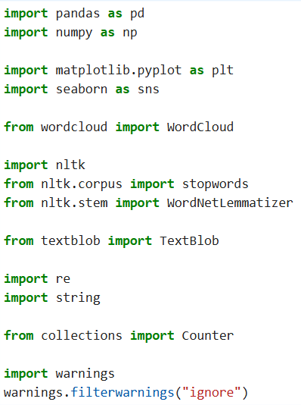

# Downloading necessary NLTK data
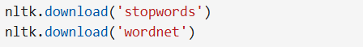
# Loading the dataset
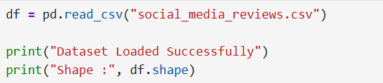

6.2 Data Cleaning & Preprocessing
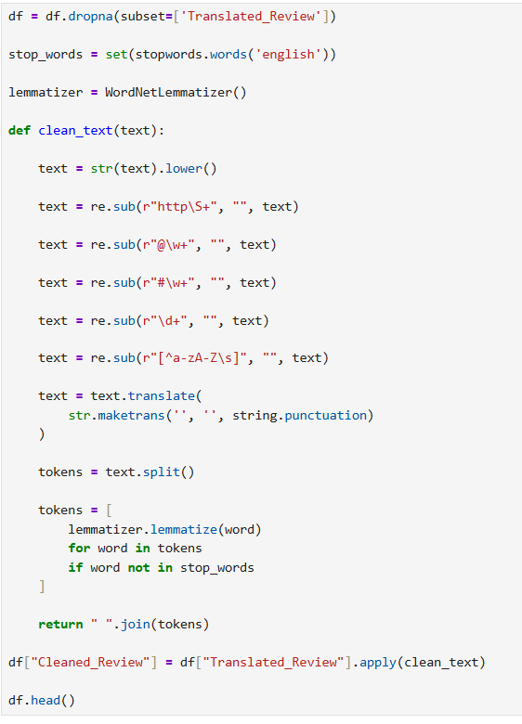

6.3 Sentiment Classification Logic
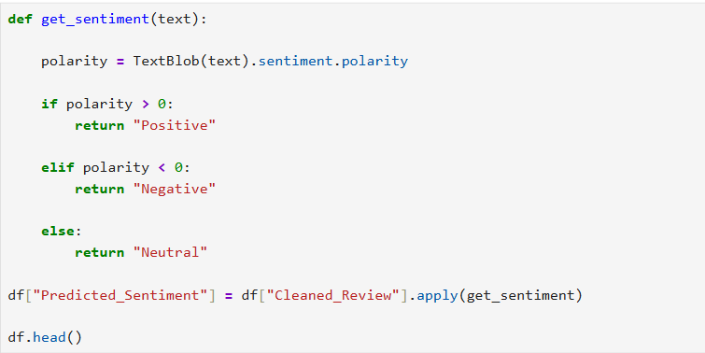
6.4 Visualizations Generation
1. Code For Sentiment Distribution Pie Chart
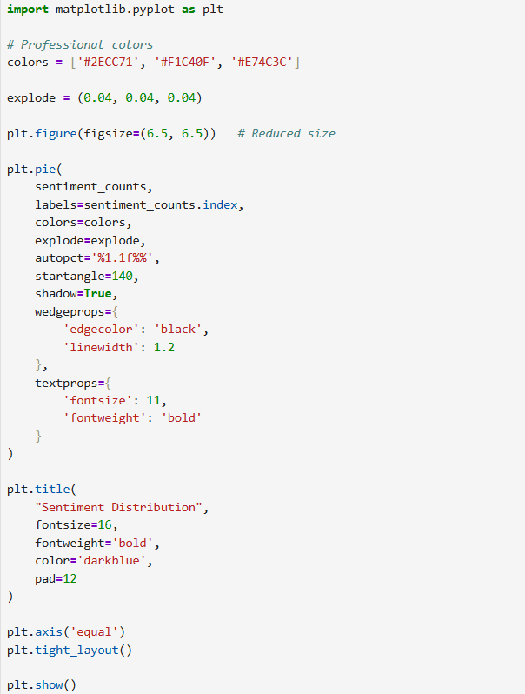
2. Code For Review Length Histogram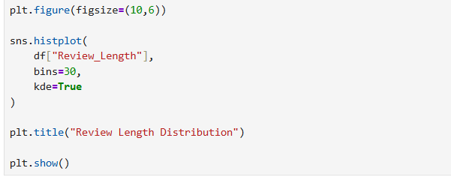
3. Code For Positive Word Cloud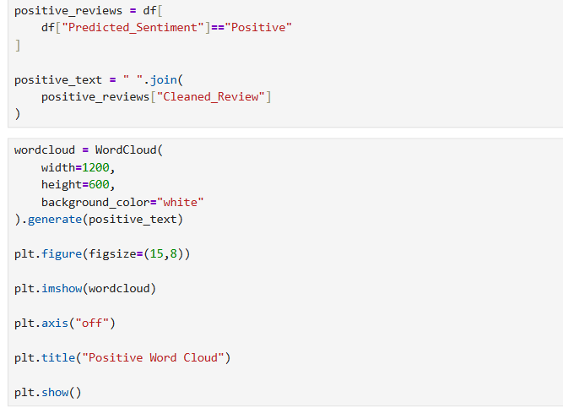

4. Code For Negative Word Cloud
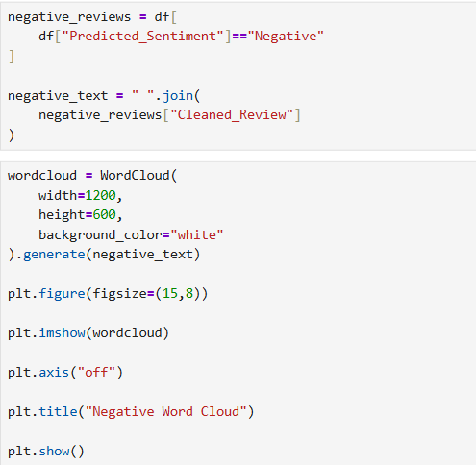
5. Code For Missing Values Heatmap
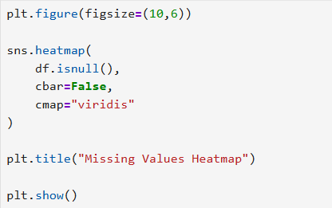

Visualizations Output
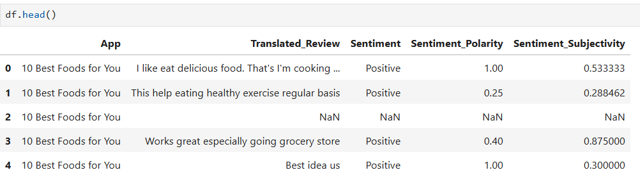
- Output of df.head() showing the raw structure of the Google Play Store dataset before cleaning.

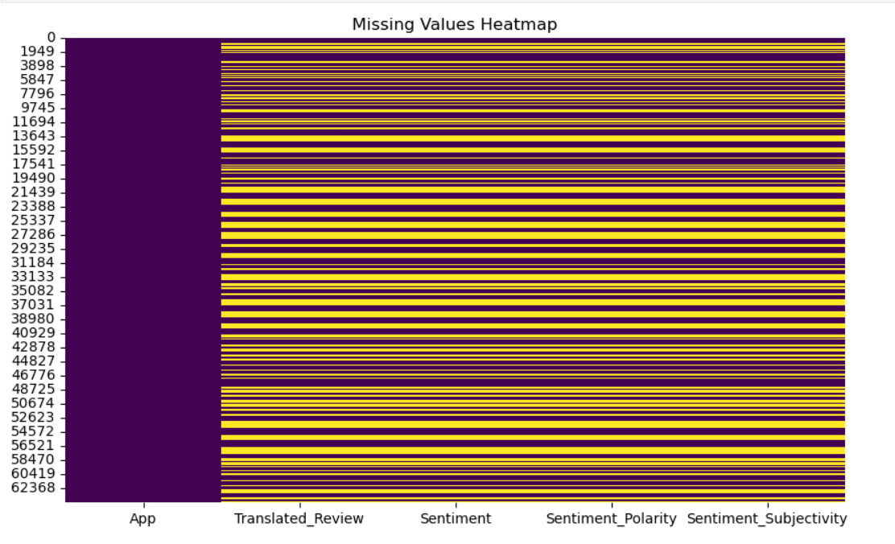
- Seaborn Missing Values Heatmap highlighting the NaN records that required removal.
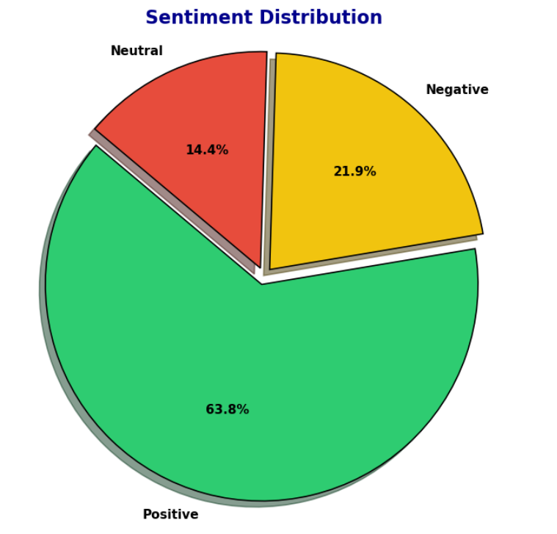
- Pie Chart showing the macro-level distribution of Positive, Negative, and Neutral sentiments.
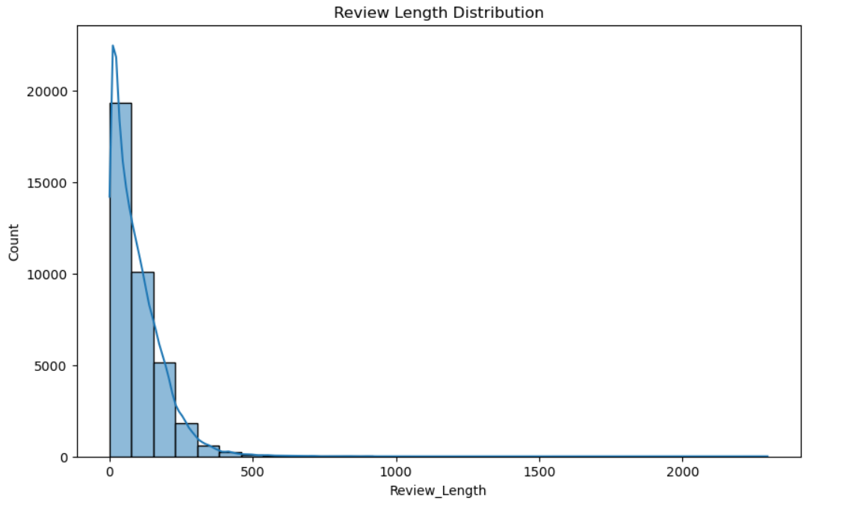
- Histogram plotting the frequency distribution of the engineered Review_Length feature.
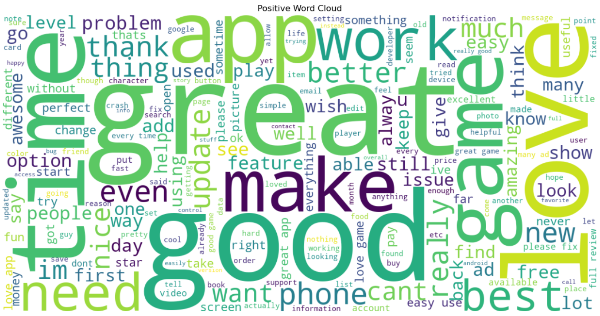
- The Positive Word Cloud generated using Matplotlib, illustrating features users praise (e.g., "good", "great", "easy").
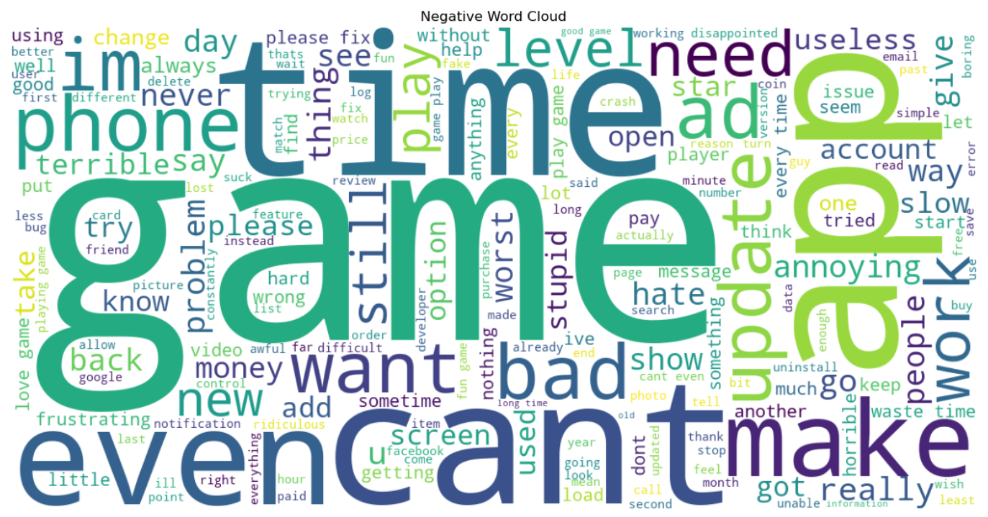
- The Negative Word Cloud generated using Matplotlib, acting as a bug report highlighting pain points (e.g., "crash", "update", "error").

ADVANTAGES
The implementation of this NLP Sentiment Analysis pipeline offers numerous operational and business advantages:
- Proactive Bug Tracking & Issue Identification: By isolating the negative sentiment dataframe, Quality Assurance (QA) teams can identify critical regressions immediately. If an update causes widespread crashes, the pipeline flags the keyword "crash" instantly, bypassing the wait time for formal support tickets.
- Data-Backed Product Roadmaps: Feature development is expensive. This analysis ensures that engineering teams build and refine features that users are actively requesting in their feedback, eliminating guesswork from product planning.
- Massive Scalability: The automated Python script processes tens of thousands of reviews in mere seconds. This provides a level of analytical scalability that manual reading cannot match, saving organizations hundreds of hours in manual data entry.
- Reduction of Human Bias: Manual review analysis is often skewed by the emotional state of the human reader. The TextBlob algorithmic approach provides objective, mathematical sentiment scoring, ensuring consistent data classification.
- Competitor Benchmarking: This pipeline is highly adaptable. It can easily be redirected to analyze a competitor’s app reviews, revealing their UX weaknesses and allowing a company to capitalize on those failures.
- Cost-Effectiveness: Built entirely on open-source Python libraries (Pandas, NLTK, Matplotlib), this solution requires zero licensing fees, making it highly accessible for startups and enterprise organizations alike.

CONCLUSION

The findings of this project conclusively demonstrate the power of integrating Natural Language Processing with traditional data analytics. By moving beyond simple numerical star ratings and deeply analyzing the actual semantic text of customer reviews, unstructured social noise was successfully transformed into structured, actionable business intelligence.
The successful deployment of Python, Pandas, Matplotlib, and NLTK in this project allowed for the rapid identification of software bugs, UX friction points, and successful product features. The automated cleaning and lemmatization pipeline ensured high data integrity, while the visual dashboards made complex text frequencies easily interpretable for non-technical stakeholders. Ultimately, this automated sentiment analysis framework proves to be a highly effective, scalable, and essential tool for product managers striving to improve user satisfaction, reduce application churn, and drive continuous software innovation.

REFERENCE WEBSITE NAMES OR LINKS

- Kaggle Datasets: Google Play Store Apps & Reviews Dataset. Retrieved from: https://www.kaggle.com
- Pandas Official Documentation: Data structures and data analysis tools for Python. Retrieved from: https://pandas.pydata.org/docs/
- Natural Language Toolkit (NLTK) Documentation: Library for building Python programs to work with human language data. Retrieved from: https://www.nltk.org/
- TextBlob Documentation: Simplified Text Processing and Sentiment Analysis. Retrieved from: https://textblob.readthedocs.io/en/dev/
- Matplotlib Documentation: Comprehensive library for creating static, animated, and interactive visualizations. Retrieved from: https://matplotlib.org/stable/index.html
- Seaborn Documentation: Statistical Data Visualization. Retrieved from: https://seaborn.pydata.org/
- Analytics Vidhya: Data Analysis Projects and Python NLP tutorials. Retrieved from: https://www.analyticsvidhya.com/
- APSSDC (Andhra Pradesh State Skill Development Corporation): Internship and Skill Training Resources. Retrieved from: https://www.apssdc.in/

